The Prototype Design

**Topic:** Research on Chest X-rays to deduct various respiratory infections

As per the definition of prototype, it is an experimental model of the proposed solution that we can use to test our ideas. For my research I have divided my prototype design into two conceptualised dependent model so that it will be easy to test and change the model if we want in the future.

**Prototype for Noise Cancelling:**

After collecting the chest x-ray dataset I am going to build a model to convert the given images to HSV and Gray scale images by using OpenCV library. With the help of same library I will apply the different types of noise detecting and removing algorithms such that it will remove different type of noisy data on the image. In the next step I will store all the output images to different folders based on the filter name so, that it will helpful while applying the detecting algorithm and severity model. The main advantage of doing this is to test the same image by removing different noisy data on it if we do so I hope I will get good results with more accuracy.

In the same way, we will take sample of testing images to test the model on both diseases.

The sample Prototype diagram is shown in below

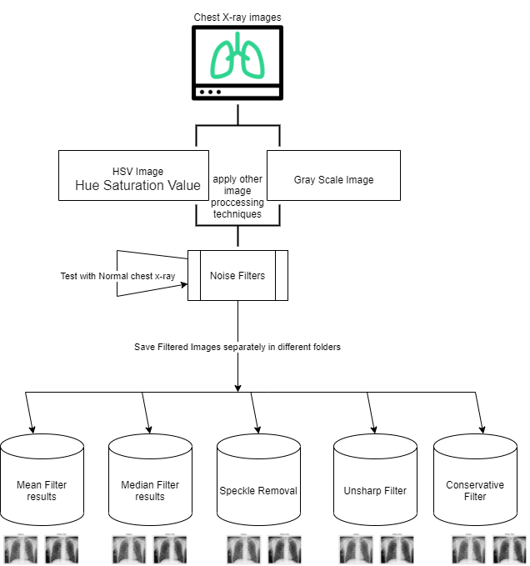

**Prototype for Severity of the Disease:**

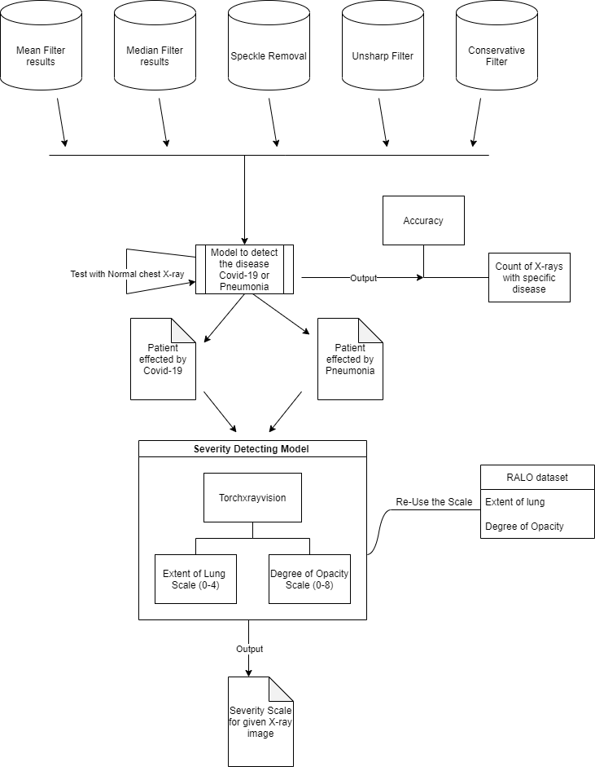In the Second phase of my research, I will develop a model to detect the disease affected to the human based on the chest x-ray it may be Covid-19 or Pneumonia. This model will give Total accuracy for given dataset and the table which specifies number of the x-rays those are effected by specific disease.

In the next step as shown in above diagram, severity can be calculated by using RALO dataset given by the radiologists. This severity model will take specific disease chest x-ray as an input and will give severity scale in the form extent of lung and degree of opacity. As per know, my idea is to develop the severity model to take only one input image to detect the severity of the disease.

**Sample Expected Outputs:**

**Filter output:**

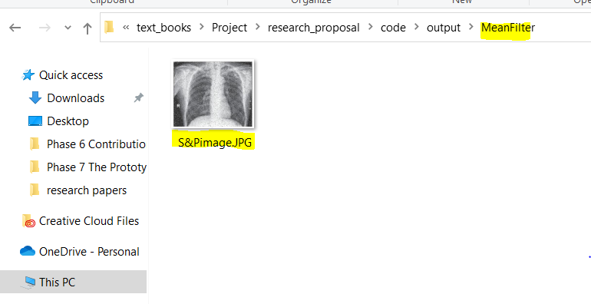

**Detection model output:**

**Accuracy: 80.678%**

**Test Accuracy: 75.890%**

|  |  |
| --- | --- |
| **Disease Name** | **Count** |
| Covid-19 | 40 |
| Pneumonia | 60 |

**Sample Severity Output:**

|  |  |
| --- | --- |
| Extent of lung | 2.6 |
| Opacity | 4 |